# GPS BASED ATTENDANCE SYSTEM

## A PROJECT REPORT

***Submitted by***

## Tej Dekiwadiya

### 92100103011

## Utsav Khunt

### 92100103007

## Soham Nagpara

### 92100103034

## BACHELOR OF TECHNOLOGY

***in***

### Computer Engineering



## Marwadi University, Rajkot

**April, 2024**

**Mini Project (01CE0609)**

**Marwadi University**

**Faculty of Technology**

Department of Computer Engineering

**2023-24**

**CERTIFICATE**

This is to certify that the project report submitted along with the project entitled **GPS Based Attendance System** has been carried out by **Tej Dekiwadiya** (92100103011)**, Utsav Khunt** (92100103007) **and Soham Nagpara** (92100103034) under my guidance in partial fulfilment for the degree of Bachelor of Technology in Computer Engineering, 6th Semester of Marwadi University, Rajkot during the academic year 2023-24.

Prof. Samir Kariya Dr. Krunal Vaghela

Assistant Professor Associate Professor

Internal Guide Head of the Department

## Marwadi University

**Rajkot**

# DECLARATION

We hereby declare that the **Mini Project (01CE0609)** report submitted along with the Project entitled **GPS Based Attendance System** submitted in partial fulfilment for the degree of Bachelor of Technology in Computer Engineering to Marwadi University, Rajkot, is a bonafide record of original project work carried out by me / us at Marwadi University under the supervision of **Prof. Samir Kariya** and that no part of this report has been directly copied from any students’ reports or taken from any other source, without providing due reference.

Name of the Student Sign of Student

1. Tej Dekiwadiya _______________
2. Utsav Khunt _______________
3. Soham Nagpara _______________

# Acknowledgement

We would like to extend our sincere appreciation to **Assistant Pro. Samir Kariya**, our esteemed mentor, for providing us with the invaluable opportunity to embark on the **"GPS Based Attendance System"** project. Prof. Samir’s guidance, expertise, and unwavering support have been pivotal throughout every phase of development. His insightful feedback and encouragement have not only refined our technical skills but also enriched our understanding of the subject matter. We are deeply grateful for his mentorship, which has played a significant role in the successful completion of our project.

In addition, we express our heartfelt thanks to my colleagues for their continuous support and encouragement. Their belief in our capabilities and their willingness to lend a helping hand whenever needed have been indispensable. Their unwavering encouragement has motivated us to push our boundaries and overcome challenges, ultimately ensuring the timely completion of the project.

**Tej Dekiwadiya**

**Utsav Khunt**

**Soham Nagpara**

# Abstract

*The "GPS-Based Attendance System" is a modern solution crafted using the MERN stack, designed to simplify the hassle of attendance tracking. Our goal with this project is to revolutionize attendance management by utilizing the familiar technology of GPS and the unique MAC addresses of users' devices. When a user signs up, their device's MAC address is securely stored in our database for future authentication. During login attempts, we ensure the legitimacy of the user's device by verifying its MAC address against the stored one, ensuring only authorized devices gain access. To prevent misuse, we've integrated real-time location tracking, allowing us to verify that the user is within the specified range set by the administrator before allowing attendance marking. This innovative feature not only enhances security but also ensures the accuracy of attendance records. With our system, organizations can bid farewell to manual attendance processes and embrace a seamless, reliable, and efficient solution that saves time and reduces administrative burden. By harnessing GPS technology and real-time location tracking, our "GPS-Based Attendance System" aims to redefine attendance management, offering a user-friendly and robust solution for modern organizations..*

### List of Figures

### 

Fig 1.7.1 Gantt Chart Of Project Workflow........................................................................ 05

Fig 3.2.1 Use case Diagram ................................................................................................ 16

Fig 3.2.2 Sequence Diagram ............................................................................................... 17

Fig 3.2.3 ER Diagram ......................................................................................................... 17

Fig 3.2.4 Flow Chart (Before Login.................................................................................... 18

Fig 3.2.5 Flow Chart (After Login...................................................................................... 19

Fig 3.2.6 Security Process Diagram.................................................................................... 20

Fig 4.3.1 Login Page........................................................................................................... 24

Fig 4.3.2 Register Page....................................................................................................... 24

Fig 4.3.3 Home Page........................................................................................................... 25

Fig 4.3.4 Home Page........................................................................................................... 25

Fig 4.3.5 Home Page........................................................................................................... 26

Fig 4.3.6 Home Page........................................................................................................... 26

Fig 4.3.7 History Page......................................................................................................... 27

Fig 4.3.8 Download Page.................................................................................................... 27

Fig 4.3.9 Profile Page.......................................................................................................... 28

Fig 4.3.10 Home Page......................................................................................................... 28

Fig 4.3.11 Find Page........................................................................................................... 29

Fig 4.3.12 Find Page........................................................................................................... 29

Fig 4.3.13 Find Page........................................................................................................... 30

Fig 4.3.14 Download Page................................................................................................. 30

Fig 4.3.15 Profile Page....................................................................................................... 31

## List of Tables

Table 5.2.1 Test Result And Analysis............................................................................... 32

### Table of Contents

Acknowledgement................................................................................................................... i

Abstract .................................................................................................................................. ii

List of Figures ...................................................................................................................... iii

List of Tables ........................................................................................................................ iv

Table of Contents .................................................................................................................. v

**Chapter 1 Introduction**.........................................................................................................1

1.1 Project Summary.............................................................................................................. 1

1.2 Purpose ............................................................................................................................ 1

1.3 Objective ..........................................................................................................................2

1.4 Scope ............................................................................................................................... 2

1.5 Technology and Literature Review.................................................................................. 2

1.6 Project Scheduling.............................................................................................................4

1.7 Project Effort and Time, Cost Estimationh........................................................................5

1.8 Roles and Responsibilities.................................................................................................5

**Chapter 2 System Analysis**.................................................................................................. 6

2.1 Study of Current System................................................................................................... 6

2.2 Problem and Weaknesses of Current System................................................................... 6

2.3 Requirements of New System.......................................................................................... 7

2.4 System Feasibility........................................................................................................... 8

2.4.1 Does the system contribute to the overall objectives of the organization?................... 8

2.4.2 Can the system be implemented using the current technology and within the given cost and schedule constraints................................................................................................. 8

2.4.2 Can the system be integrated with other systems which are already in place? ........... 9

2.5 Activity / Process in New System / Proposed System ................................................... 9

2.6 Features of New System / Proposed System.................................................................. 10

2.7 List Main Modules / Components / Processes / Techniques of New System / Proposed System.................................................................................................................................. 11

2.8 Selection of Hardware / Software / Algorithms / Methodology / Techniques / Approaches and Justification............................................................................................... 12

**Chapter 3 System Design**................................................................................................... 15

3.1 System Design & Methodology .................................................................................... 15

3.2 Database Design / Data Structure Design / Circuit Design / Process Design / Structure Design.................................................................................................................................. 16

**Chapter 4 Implementation**................................................................................................ 21

4.1 Process / Program / Technology / Modules Specification(s)......................................... 21

4.2 Implementation of Platform / Environment References................................................ 23

4.3 Finding / Results / Outputs............................................................................................ 24

**Chapter 5 Testing**.............................................................................................................. 32

5.1 Testing Plan / Strategy.................................................................................................. 32

5.2 Test Results and Analysis.............................................................................................. 32

5.2.1 Test Cases (test ID, test condition, expected output, actual output, remark)............. 32

**Chapter 6 Conclusion & Outcomes**..................................................................................33

6.1 Overall Analysis of Project Viabilities.......................................................................... 33

6.2 Problem Encountered and Possible Solutions............................................................... 33

6.3 Summary of Project work............................................................................................. 34

6.4 Limitations and Future Enhancement........................................................................... 34

6.5 Project Outcomes.......................................................................................................... 35

**References**......................................................................................................................... 36

# CHAPTER 1

**INTRODUCTION**

1. **PROJECT SUMMARY**

The GPS-Based Attendance System represents a significant advancement in attendance management, promising to transform traditional processes into streamlined, automated procedures. By harnessing the power of GPS technology, this system eliminates the manual burden of attendance tracking, enabling organizations to achieve newfound efficiency and accuracy in record-keeping. Real-time data synchronization ensures that attendance records are always up-to-date, providing administrators with timely insights into attendance trends and patterns. The system's customizable reporting feature empowers decision-makers to derive actionable insights from attendance data. With robust authentication mechanisms in place, the system ensures the security and integrity of attendance records, bolstering trust and accountability within the organization. Its scalability and integration capabilities make it adaptable to organizations of varying sizes and seamlessly compatible with existing management systems. Overall, the GPS-Based Attendance System offers a comprehensive solution that not only saves time and resources but also enhances transparency and operational effectiveness in attendance management.

1. **PURPOSE**

The purpose of the GPS-Based Attendance System is to modernize and optimize attendance tracking processes within organizations. By leveraging GPS technology and GPS technology, the system aims to automate the tedious task of attendance management, thereby reducing administrative burden and potential errors associated with manual data entry. The system's primary objective is to streamline attendance tracking, improve accuracy, enhance efficiency, and increase transparency in organizations of all sizes. Ultimately, the purpose of this system is to provide a reliable, real-time solution for managing attendance that aligns with the evolving needs and demands of modern workplaces and educational institutions.

1. **OBJECTIVE**

* Automate attendance tracking processes
* Improve accuracy of attendance records
* Enhance efficiency in attendance management
* Increase transparency with real-time access to data
* Ensure seamless integration with existing systems
* Enhance security measures for data protection
* Align with organizational needs and requirements

1. **SCOPE**

The scope of the GPS-Based Attendance System involves developing software for automated attendance tracking, ensuring seamless integration with existing GPS infrastructure and GPS. It encompasses real-time data synchronization, customizable reporting features, and robust security measures for data protection. Additionally, the project includes training sessions, support services, and scalability considerations to meet organizational needs efficiently.

1. **TECHNOLOGY AND LITERATURE REVIEW**

**Technology:**

Our project, leveraging the MERN (MongoDB, Express.js, React, Node.js) technology stack to create a robust, scalable, and user-friendly solution that connects local service providers with individuals seeking services within their community. The MERN stack's strength lies in its ability to provide a full-stack JavaScript development environment, fostering code reuse and making it easier for developers to switch between the server and client sides. This stack is widely adopted for its flexibility, scalability, and efficiency in developing modern, single-page applications (SPAs) and other web-based projects.

Here's a brief description of each technology within the MERN stack:

* **React:**

React is a powerful JavaScript library for building user interfaces. Developed and maintained by Facebook, React enables developers to create interactive and dynamic front-end applications with a component-based architecture. Its virtual DOM (Document Object Model) enhances performance by efficiently updating only the necessary parts of a web page, resulting in a smoother and more responsive user experience.

* **Express.js:**

Express.js is a lightweight and flexible Node.js web application framework that simplifies the development of server-side applications. It provides a set of robust features for building web and mobile applications, including routing, middleware support, and the ability to create RESTful APIs. Express.js facilitates the rapid development of scalable and maintainable server-side components.

* **MongoDB:**

MongoDB is a NoSQL, document-oriented database that stores data in a flexible, JSON-like format. It allows developers to handle large volumes of data and complex structures with ease. MongoDB's scalability and versatility make it an ideal choice for applications with evolving and dynamic data requirements.

* **Node.js:**

Node.js is a server-side JavaScript runtime that enables the execution of JavaScript code outside of a web browser. It uses an event-driven, non-blocking I/O model, making it efficient for building scalable and real-time applications. Node.js is particularly well-suited for creating server-side components in MERN applications, ensuring a unified JavaScript stack from front to back

**Literature Review:**

**Title**: GPS Based Attendance System (By ANITS)

**Description:** The Wi-Fi based attendance system for this project is targeted towards making taking of class attendance much easier and leaving teachers with adequate time to concentrate on their work activity. The system includes an automatic Wi-Fi hotspot activation by the teacher during each lecture, with students connecting via a mobile application to scan a QR code and enter their details for marking attendance. The project aims to optimise the attendance system in classroom management.

* **Advantages of the Project:**

1. Efficient Attendance Tracking
2. Streamlined Process
3. Time-Saving
4. Real-Time Tracking

* **Limitations of the Project:**

1. Dependency on Technology
2. Initial Setup
3. Security Concerns
4. **PROJECT SCHEDULING**

Project scheduling is planning of activity in project. For g scheduling the plan of project, software project manager wants to do following:

1. Identification of functions required to complete the project
2. Breaking functions in to small activities
3. To having the control among various activities
4. Planning the starting and finishing dates for activities
5. Deciding the duration of project
6. Allocating resources
7. **PROJECT EFFORT AND TIME, COST ESTIMATION**

The project was given us on Jan-05. The time was managed between we 3 team members. We were supporting each other through sharing our ideas for project.

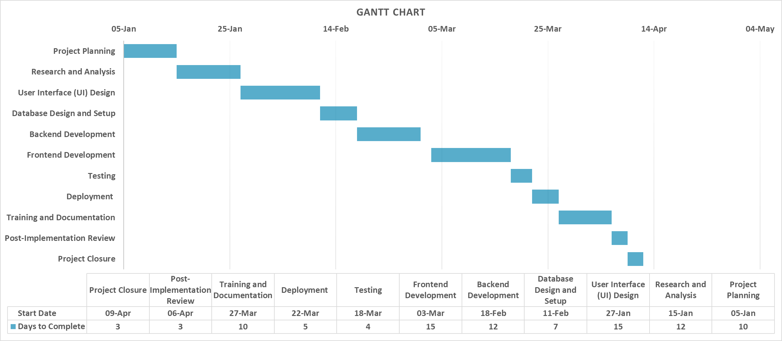

Fig. 1.7.1 Gantt Chart of Project Workflow

1. **ROLES AND RESPONSIBILITIES**

* The project planning & selection of topic was done by three members of our team. We are trying to execute our thinking about website through this project. We have solved the issues thar occur in our project.
* We have managed the time & distributed work between us. The communication was good between us so there was no issue of implementing.

# CHAPTER 2

**SYSTEM ANALYSIS**

* 1. **STUDY OF CURRENT SYSTEM**

The existing system utilizes the Wi-Fi technology to create a seamless and efficient way of tracking student attendance. During each class session, the respective teacher generates a Wi-Fi hotspot within the classroom. Students can then connect to this hotspot using a mobile application on their smartphones. By scanning a QR code generated by the teacher and entering their details through the app, students can effectively mark their attendance without the need for manual intervention.

Furthermore, the system leverages technologies such as XAMPP server, Kodular app development platform, and Android mobile applications to facilitate seamless integration and operation. The XAMPP server plays a crucial role in enabling communication between the teacher's hotspot and students' mobile devices, ensuring secure and reliable data transmission. The Kodular app development platform offers a user-friendly interface for creating the necessary applications to support the attendance system.

* 1. **PROBLEM AND WEAKNESSES OF CURRENT SYSTEM**
* **Dependency on Technology:**

The system entails technology such as a good Wi-Fi connection and mobile devices. Any technical issues related to Wi-Fi network, as well as with the mobile application, could create disruptions in the process of attendance marking.

* **User Training and Adoption:**

The introduction of such technology-enhanced system demands the instructors and the learners to undergo training to ensure they are familiarized with the new system. Teacher must be capable on starting the Wi-Fi hotspot and also students must be trained on how to log into Wi-Fi hotspot, use the QR code, or enter correctly their details.

* **Privacy and Data Security Concerns:**

The system needs to ensure that student information is securely stored and protected from unauthorized access. In the event of a data breach or security vulnerability, sensitive student data could be compromised, leading to potential legal and ethical implications.

* **Technical Challenges and Maintenance:**

Regular updates and maintenance are necessary to ensure the system functions smoothly. Technical issues like device compatibility, software updates, and network configuration may arise, requiring dedicated IT support to address them promptly.

* 1. **REQUIREMENTS OF NEW SYSTEM**

**Hardware Requirements:**

* **Server:** To host our MERN stack application.
* **Networking Equipment:** Reliable GPS routers/access points to ensure stable connectivity for users.
* **Client Devices:** Devices capable of connecting to GPS, running a web browser and providing precise location for accessing the system.

**Software Requirements:**

* **Operating System:** Windows or Ubuntu.
* **Database:** MongoDB for storing user data including MAC addresses and attendance records.
* **Backend:** Node.js for server-side scripting and Express.js for building RESTful APIs.
* **Frontend:** React.js for the user interface.
* **Geolocation Services:** Geolocation APIs to verify the user's live location and compare it with the predefined range for attendance marking.
* **Dependency Management:** npm or Yarn for managing project dependencies.

**Security Requirements:**

* **Encryption:** Ensure secure communication between the client and server using HTTPS.
* **Input Validation:** Implement strict input validation to prevent injection attacks.
* **Authentication:** MAC addresses/IP address.

**Testing and Quality Assurance:**

* Comprehensive testing including unit tests, integration tests, and end-to-end tests to ensure the system works as expected and meets user requirements.
  1. **SYSTEM FEASIBILITY**
     1. **DOES THE SYSTEM CONTRIBUTE TO THE OVERALL OBJECTIVES OF THE ORGANIZATION?**

The system significantly contributes to the organization's objectives by streamlining attendance management processes. By automating attendance tracking, it boosts operational efficiency, allowing staff to focus on core activities. Moreover, insights derived from attendance data aid in resource optimization, leading to improved productivity and cost savings. Implementing a modern attendance system demonstrates the organization's commitment to employee well-being, fostering a positive work environment and enhancing satisfaction. Overall, the system aligns with organizational goals, promoting efficiency, compliance, resource optimization, and employee engagement.

* + 1. **CAN THE SYSTEM BE IMPLEMENTED USING THE CURRENT TECHNOLOGY AND WITHIN THE GIVEN COST AND SCHEDULE CONSTRAINTS.**

Given the current technology landscape and budget constraints, implementing the system appears feasible. Leveraging existing GPS technology and MERN stack components, development costs can be managed effectively. However, ensuring compliance with budget and schedule constraints requires careful planning and resource allocation. Collaborating closely with stakeholders, prioritizing essential features, and adopting an iterative development approach can help mitigate risks and ensure timely delivery. While challenges may arise, proactive communication and flexibility in adapting to changing requirements will be key to successful implementation within the defined constraints.

* + 1. **CAN THE SYSTEM BE INTEGRATED WITH OTHER SYSTEMS WHICH ARE ALREADY IN PLACE?**

Yes, the system can likely be integrated with other existing systems, provided they support interoperability and have compatible interfaces. Integration can facilitate seamless data exchange and enhance overall system functionality. However, compatibility checks and potential modifications may be required to ensure smooth integration without disrupting existing operations. Collaborating with stakeholders and IT teams to assess compatibility, define integration points, and implement necessary adjustments can streamline the integration process. By leveraging standardized protocols and APIs, the system can effectively communicate and share data with other systems, optimizing efficiency and maximizing the value of existing technology investments.

* 1. **PROCESS IN NEW SYSTEM:**

Process in our system involves several steps to ensure smooth operation and achieve desired outcomes. Our proposed system is designed to achieve specific objectives while prioritizing user security, data integrity, and system reliability. Here's an outline of the process flow:

1. User Registration/Signup:

* Users sign up for the system by providing necessary details.
* The system validates the information and assigns a unique identifier.
* User data, including MAC address, is securely stored in the database.

2. User Authentication/Login:

* User authenticate themselves using credentials provided during registration.
* The system verifies the credentials and grants access if valid.
* MAC address verification ensures authorized access.

3. Attendance Markin:

* Upon successful login, users can mark their attendance.
* Location verification ensures users are within the specified range for attendance marking.
* The system records the attendance along with timestamp and user details.

4. Data Processing and Storage:

* Attendance data is processed and stored securely in the database.

5. Reporting:

* Faculty can generate attendance reports for analysis and decision-making.
  1. **Features of New System:**

**User Registration:**

* Allow users to sign up for the system by providing necessary information.
* Capture and store user details including name, email, and MAC address, etc in the database.

**User Authentication:**

* Authenticate users during login using username/password credentials.
* Verify the user's MAC address to ensure device authenticity and prevent unauthorized access.

**Geolocation Verification:**

* Verify the live location of users to ensure they are within the predefined range for attendance marking.
* Utilize geolocation services to determine the user's current location accurately.

**Attendance Marking:**

* Allow users to mark their attendance only when their device is within the specified range.
* Record attendance details including time and date for each attendance mark.

**Attendance Reporting:**

* Provide users with access to attendance reports.
* Generate reports showing attendance records based on specified criteria such as date range or user.

**User Management:**

* Allow users to update their profile information and manage their account settings.

**Security Features:**

* Implement encryption mechanisms to secure communication between clients and the server.
* Use strong encryption algorithms to protect sensitive data such as passwords

**Alerts and Notifications:**

* Trigger notifications for suspicious login attempts or unauthorized access.
* Notify when the device is out of predefined range of the GPS.

**User Interface:**

* A user-friendly interface for easy navigation and interaction.
* Ensure compatibility with various devices and screen sizes for a seamless user experience.

**2.7 LIST MAIN MODULES / COMPONENTS / PROCESSES / TECHNIQUES OF NEW SYSTEM / PROPOSED SYSTEM**

**User Registration Module:**

* Capturing and storing user information including MAC address.
* Database management for user registration data.

**User Authentication Module:**

* Verification of user identity based on MAC address during login.
* Access control to grant or deny system access.

**Location Verification Module:**

* Continuous tracking of user's live location.
* Checking if the user's current location falls within the predefined range for attendance marking.

**Attendance Management Module:**

* Allowing users to mark their attendance when within the specified location range.
* Recording attendance data in the database.

**Database Management Module:**

* Storing user registration details, including MAC addresses.
* Managing attendance records and related data.

**Security Techniques:**

* MAC address authentication for user login.
* Encryption techniques to secure data transmission and storage.
* Implementing secure authentication protocols to prevent unauthorized access.

**MERN Stack Components:**

* **MongoDB:** For storing user and attendance data.
* **Express.js:** For building the backend server and handling HTTP requests.
* **React.js:** For building the frontend user interface.
* **Node.js:** For server-side scripting and backend logic execution.

**Live Location Tracking Technique:**

* Utilizing GPS or GPS signals to track the user's live location.
* Implementing algorithms to determine if the user is within the designated range for attendance marking.
  1. **Selection of Hardware / Software / Algorithms / Methodology / Techniques / Approaches and Justification**

**Hardware:**

* **Server:** High-performance server hardware with sufficient processing power, memory, and storage capacity to handle database operations, geolocation calculations, and concurrent user requests.
* **Networking Equipment:** Reliable GPS routers/ to ensure stable connectivity for users.

**Software:**

* **Operating System:** Linux-based server operating system (e.g., Ubuntu Server) for stability, security, and compatibility with open-source software.
* **Database:** MongoDB for its flexibility, scalability, and compatibility with Node.js.
* **Backend:** Node.js for server-side scripting and Express.js for building RESTful APIs.
* **Frontend:** React.js for its component-based architecture, fast rendering, and robust ecosystem of libraries and tools.
* **Geolocation Services:** Integration with geolocation APIs such as Google Maps API or OpenStreetMap for accurate location tracking.

**Algorithms:**

* **MAC Address Verification:** Utilize algorithms for comparing stored MAC addresses with login attempts to authenticate user devices.
* **Geolocation Verification:** Implement algorithms for calculating distances between user locations and predefined ranges for attendance marking.

**Methodology:**

* **Agile Methodology:** Embrace iterative development cycles, frequent testing, and continuous feedback to adapt to changing requirements and deliver incremental improvements.
* **DevOps Practices:** Incorporate automation, continuous integration, and continuous deployment (CI/CD) pipelines to streamline development, testing, and deployment processes.

**Techniques:**

* **Encryption:** Use encryption techniques such as SSL/TLS for securing communication between clients and the server.
* **Access Control:** Implement role-based access control (RBAC) to manage user permissions and restrict unauthorized access to sensitive resources.
* **Error Handling:** Employ robust error handling techniques to detect and gracefully handle errors, ensuring system reliability and stability.

**Approaches:**

* **User-Centric Design:** Adopt a user-centric approach to system design, focusing on usability, accessibility, and user satisfaction.
* **Security-First Approach:** Prioritize security throughout the development lifecycle, incorporating security measures at every layer of the application architecture.

# CHAPTER 3

**SYSTEM DESIGN**

* 1. **SYSTEM DESIGN & METHODOLOGY**
* **Requirements Gathering:** Understand stakeholder needs and define system requirements.
* **System Architecture Design:** Develop a modular architecture with frontend, backend, and database components.
* **Database Design:** Design a database to store user data, attendance records, and system configurations.
* **User Interface Design:** Create a user-friendly interface for registration, login, attendance marking, and reporting
* **Development:** Implement system components using appropriate technologies and frameworks.
* **Testing:** Conduct thorough testing, including unit tests, integration tests, and usability testing.
* **Deployment:** Deploy the system to a production environment and monitor performance.
* **Maintenance and Support:** Provide ongoing maintenance, updates, and technical support.
  1. **DATABASE DESIGN / DATA STRUCTURE DESIGN / CIRCUIT DESIGN /** **PROCESS DESIGN / STRUCTURE DESIGN ALL APPLICABLE DIAGRAMS (CLASS, USECASE, ACTIVITY, USE CASE, OBJECT, FLOW CHART ETC.)**

**Use case Diagram:**

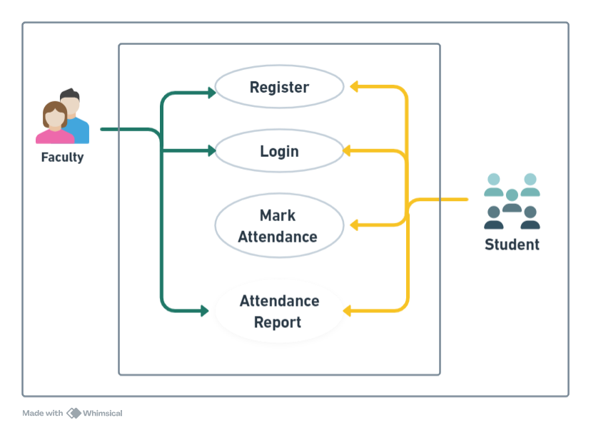

Fig. 3.2.1 Use case Diagram

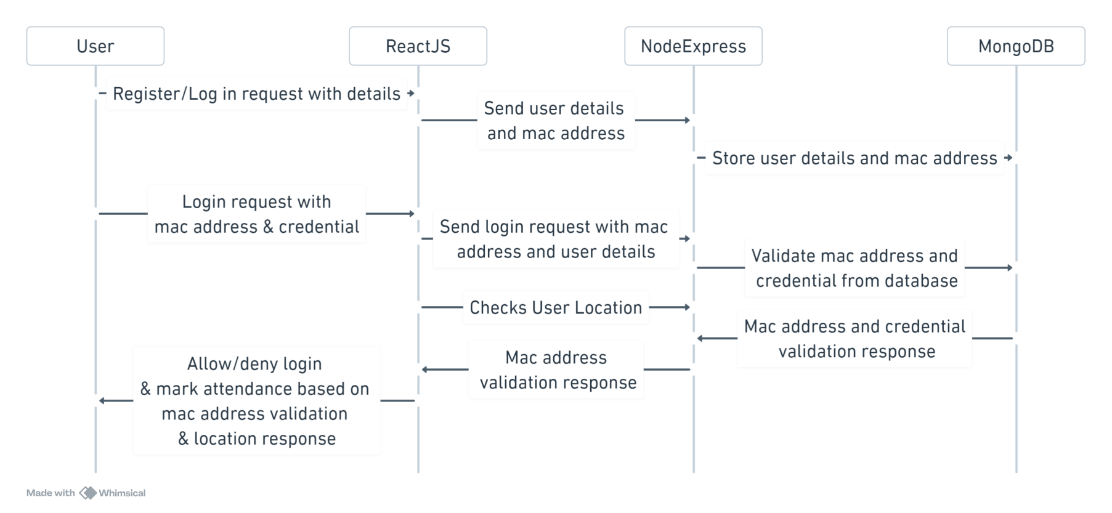**Sequence Diagram:**

Fig. 3.2.2 Sequence Diagram

**ER Diagram:**

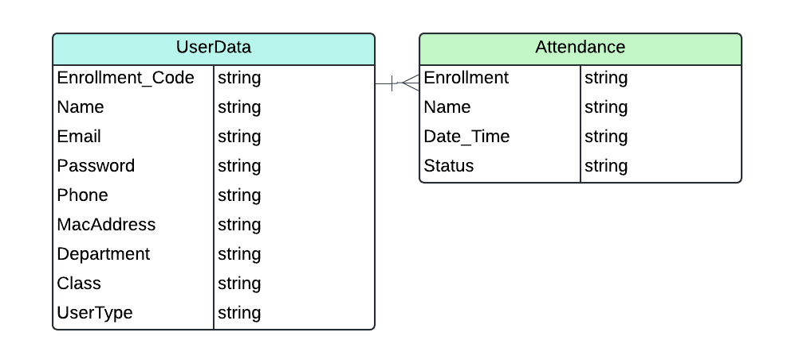

Fig. 3.2.3 ER Diagram

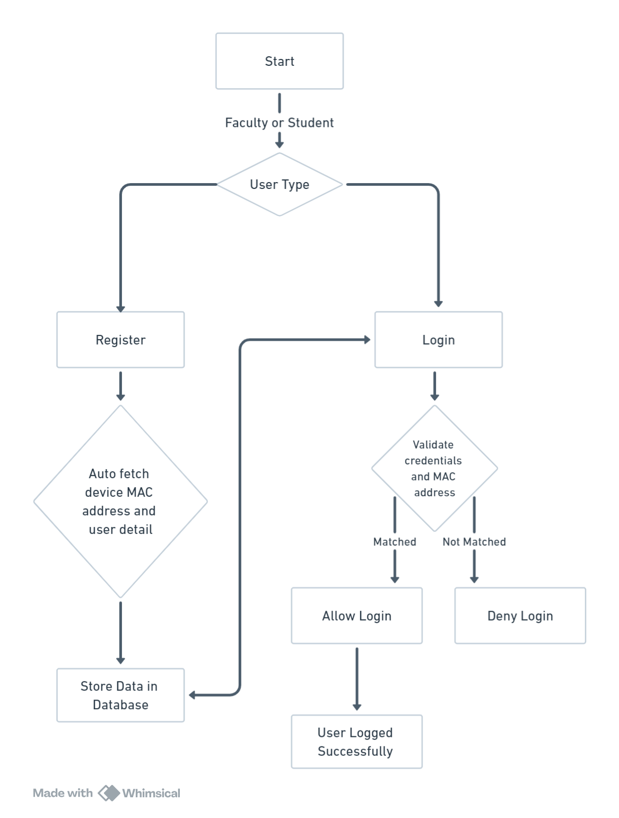**Flow Chart:**

Fig. 3.2.4 Flow Chart (Before Login)

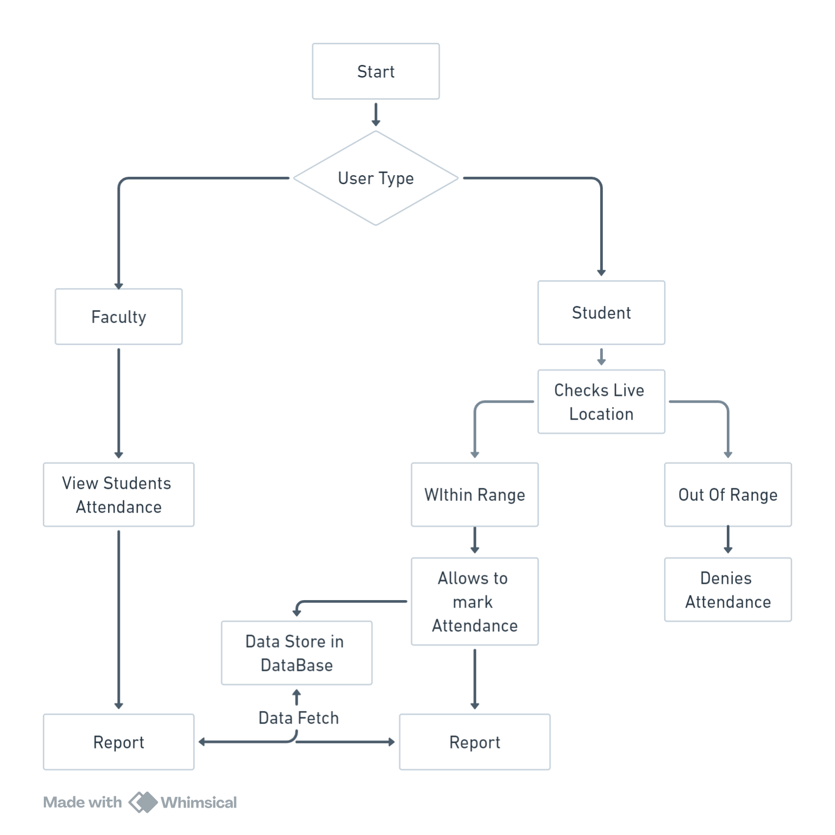

Fig. 3.2.5 Flow Chart (After Login)

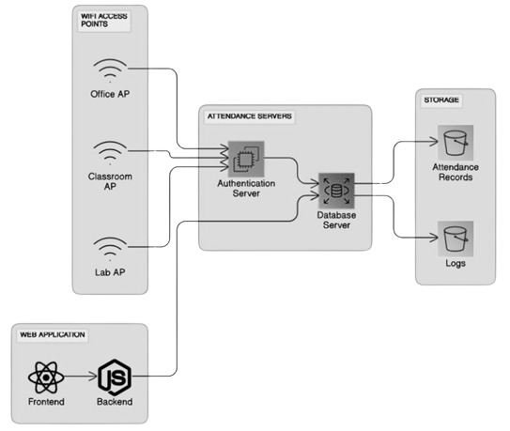**Security Process Diagram:**

Fig. 3.2.6 Security Process Diagram

# CHAPTER 4

**IMPLEMENTATION**

* 1. **PROCESS / PROGRAM / TECHNOLOGY / MODULES SPECIFICATION(S)**

**Process Specification:**

**Overview:**

* The system manages attendance by storing user MAC addresses during signup and verifying them during login.
* Live location tracking is used to allow attendance marking within a specified range.

**User Flow:**

* User signs up with MAC address -> User logs in (MAC address verification) -> User marks attendance (location check) -> Attendance recorded.

**Program Specification:**

**Backend (Node.js with Express):**

* API endpoints for user authentication (signup, login) and attendance marking.
* Database models for user data (including MAC address) and attendance records.
* Middleware for MAC address verification during login and location check during attendance marking.

**Frontend (React):**

* User interfaces for signup, login, and attendance marking.
* Forms for user input (MAC address during signup, login credentials).
* Integration with backend APIs for data exchange.

**Database (MongoDB with Mongoose):**

* User schema with fields for MAC address, login credentials, and attendance history.
* Attendance schema with fields for user ID, timestamp, and location.

**Technology Specification:**

**Backend:**

* Node.js for server-side logic.
* Express.js for API development.

**Frontend:**

* React for dynamic UI components.
* React Router for navigation between pages.
* Axios for API requests.

**Database:**

* MongoDB for NoSQL database storage.
* Mongoose for schema modeling and data validation.

**External Services:**

* Geo Location API for live location tracking.

**Modules Specification:**

**User Authentication Module:**

* API endpoints: /api/signup, /api/login.
* Middleware for MAC address verification.

**Attendance Management Module:**

* API endpoint: /api/mark-attendance.
* Location check using Jeo Location API.

**Database Interaction Module:**

* User model methods for CRUD operations.
* Attendance model methods for recording attendance.

**Security Module:**

* Encryption of sensitive data (e.g., passwords).
* HTTPS setup for secure communication.

**Error Handling Module:**

* Custom error messages for authentication failures, location out of range, etc.
* Error handling middleware for global error management.

**Deployment Module:**

* Deployment scripts for backend (Node.js server) and frontend (React app).
* Environment variable management for sensitive information.
  1. **IMPLEMENTATION OF PLATFORM / ENVIRONMENT**

**Frontend (React):**

* Create a user interface for signup, login, and attendance marking.
* Use React Router for navigation between different pages.
* Implement forms for user registration and login.
* Integrate APIs to communicate with the backend for user authentication and attendance marking.

**Backend (Node.js with Express):**

* Set up routes for user authentication (signup, login) and attendance marking.
* Use MongoDB/Mongoose for database operations to store user information and attendance data.
* Implement authentication middleware to verify the user's MAC address during login.
* Integrate libraries like express-validator for form validation and error handling.
* Utilize JSON Web Tokens (JWT) for session management and authentication.

**Database (MongoDB):**

* Design a schema for storing user details, including MAC addresses.
* Store attendance records with timestamps and location information.

**Live Location Tracking:**

* Decide on the geographical area or coordinates that define the permissible range for attendance marking. This could be defined as a radius around a specific location or a polygon outlining an area.

**Security Considerations:**

* Ensure secure storage and handling of MAC addresses and user data.
* Use HTTPS for secure communication between the client and server.
* Implement rate limiting and other security measures to prevent unauthorized access.
  1. **FINDING / RESULTS / OUTPUTS**

Here we are going to share some screenshot of resulted website:

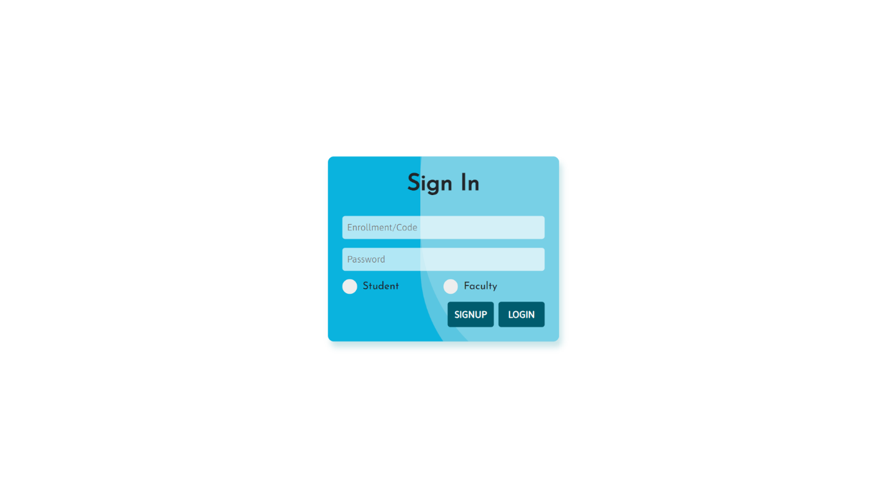

Fig. 4.3.1 Login Page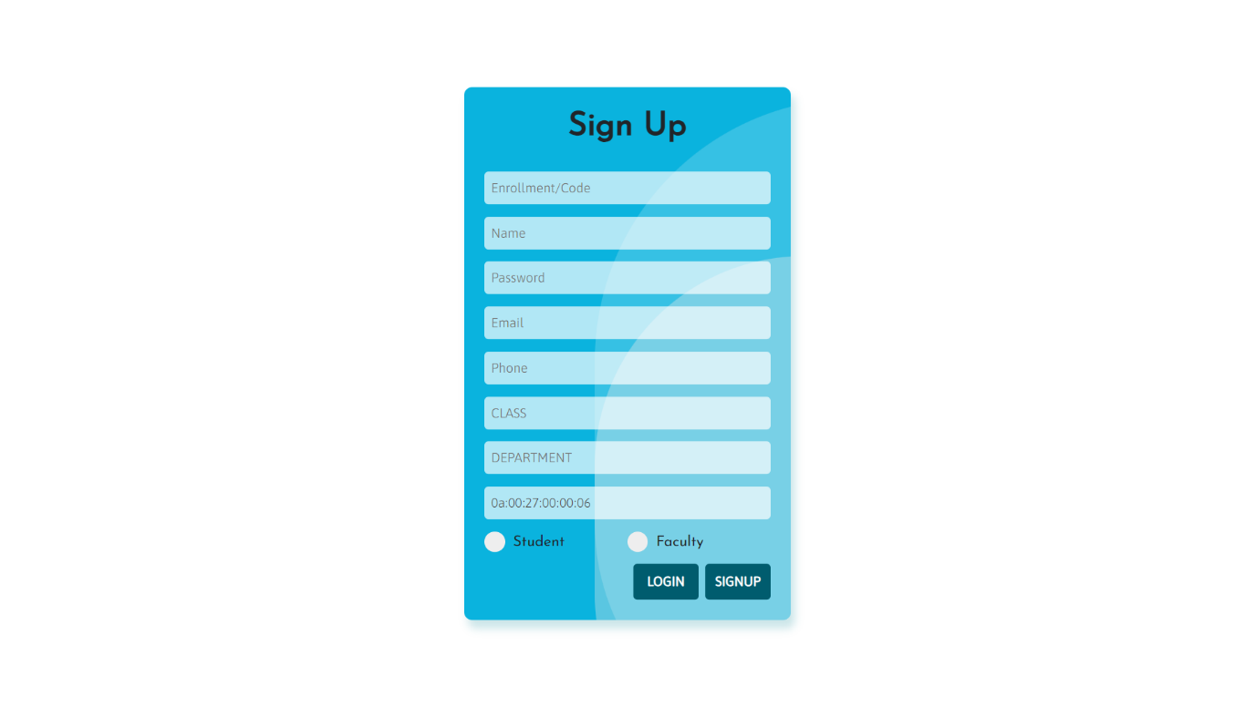

Fig. 4.3.2 Register Page

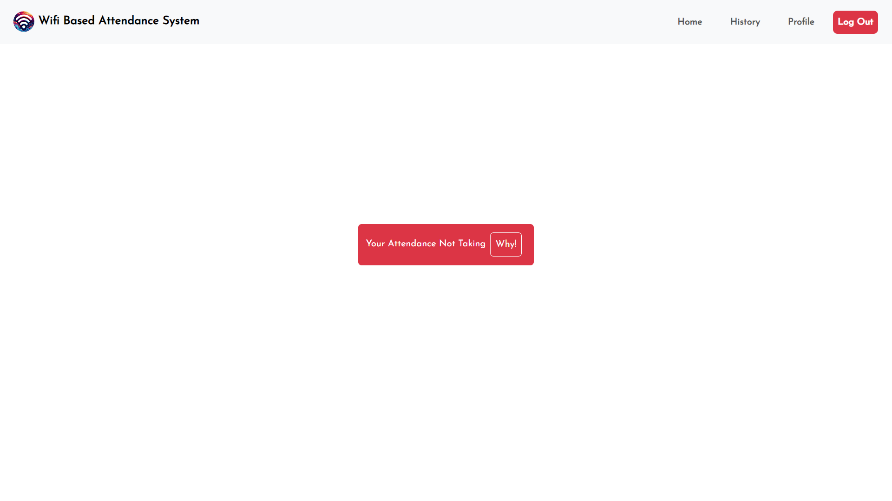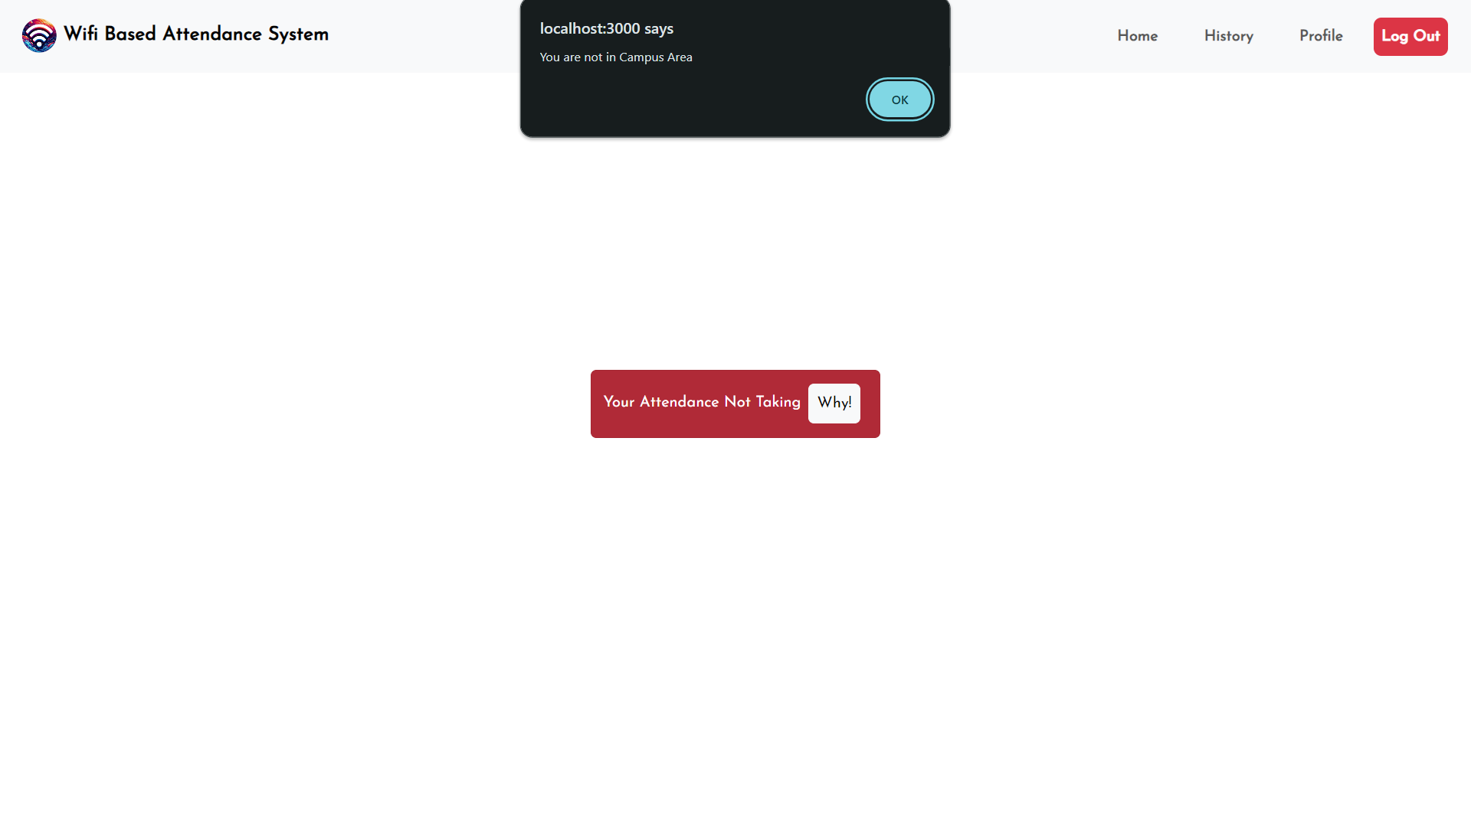

Fig. 4.3.4 Home Page

Fig. 4.3.3 Home Page

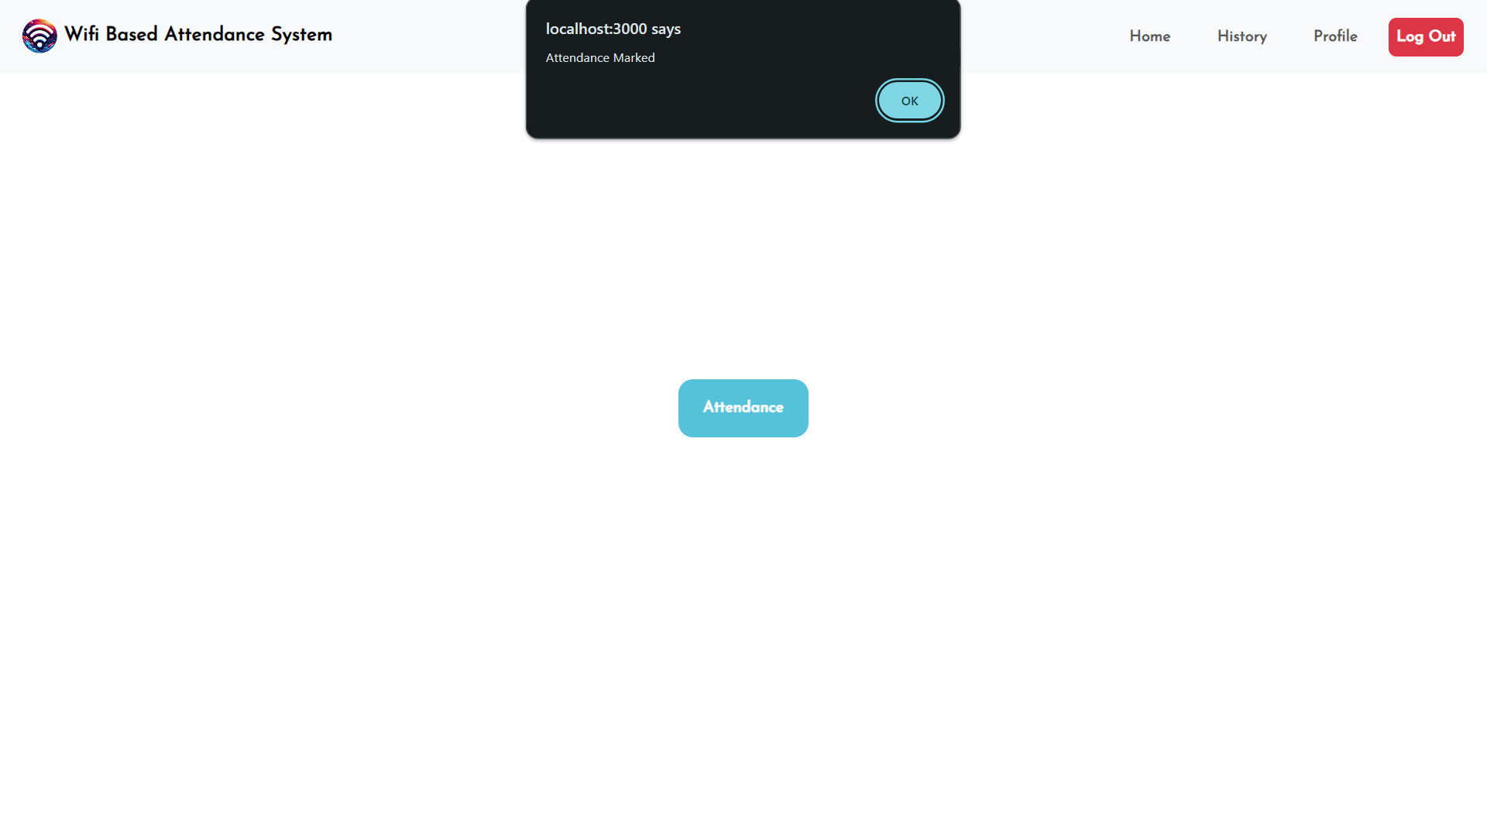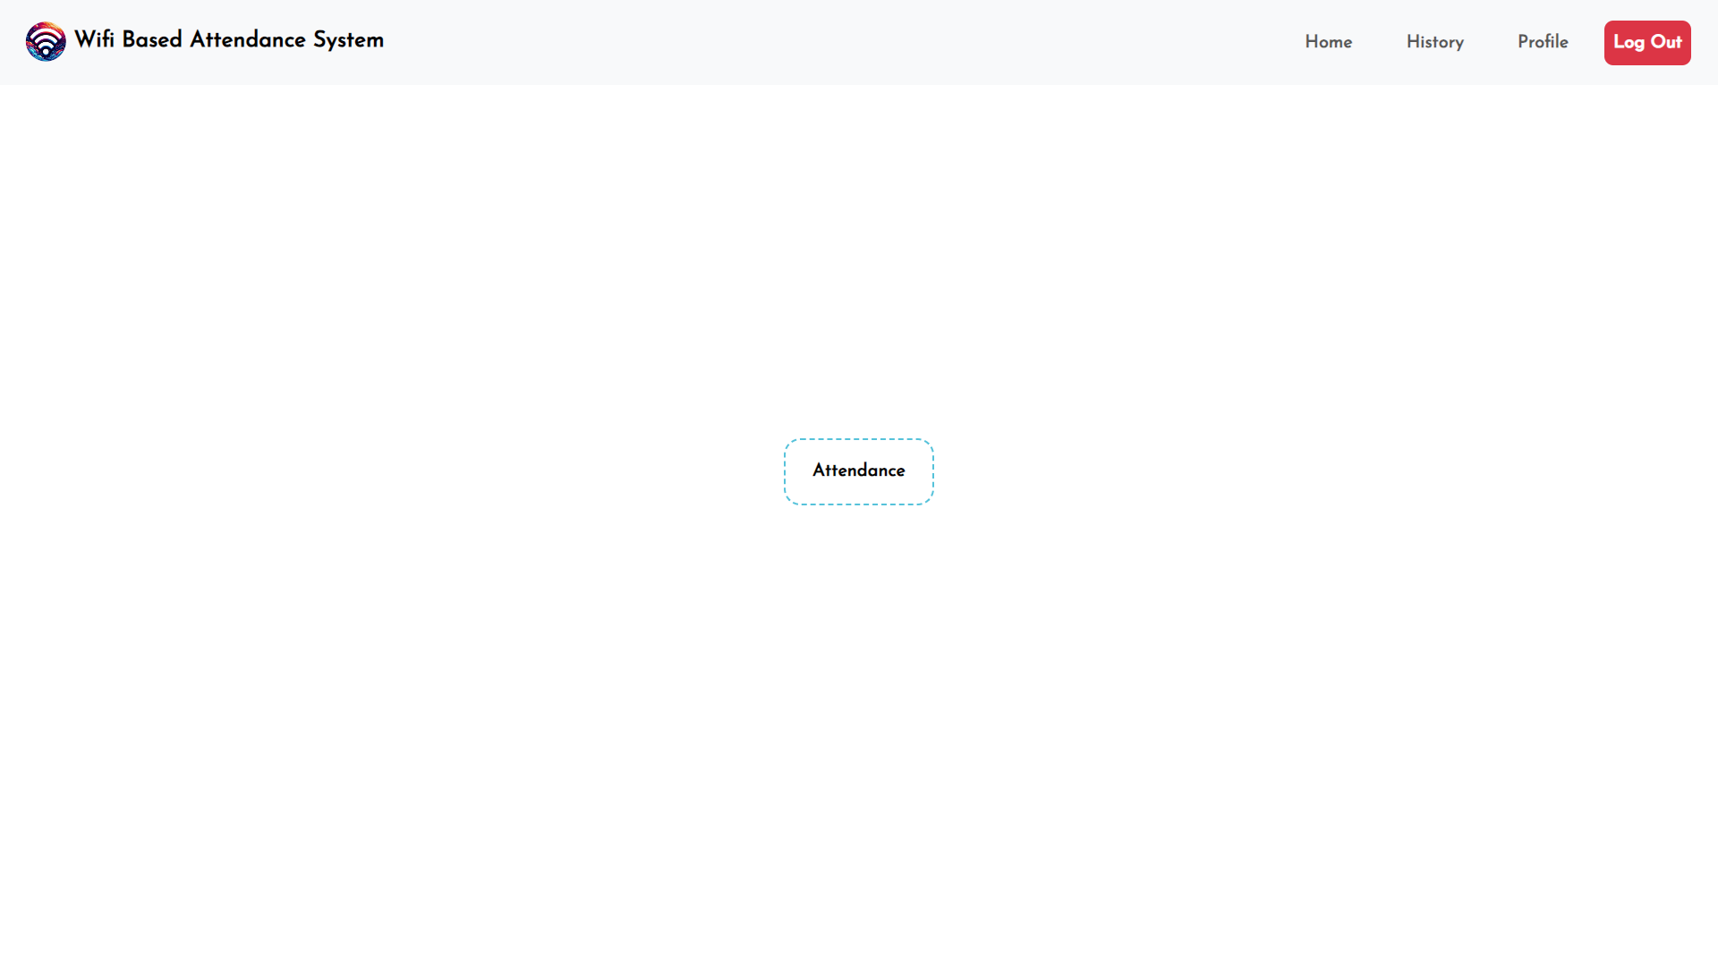

Fig. 4.3.6 Home Page

Fig. 4.3.5 Home Page

# 

Fig. 4.3.7 History Page

Fig. 4.3.8 Download Report

# 

Fig. 4.3.9 Profile Page

Fig. 4.3.10 Home Page

# 

Fig. 4.3.12 Find Page

Fig. 4.3.11 Find Page

# 

Fig. 4.3.14 Download Report Page

Fig. 4.3.13 Find Page

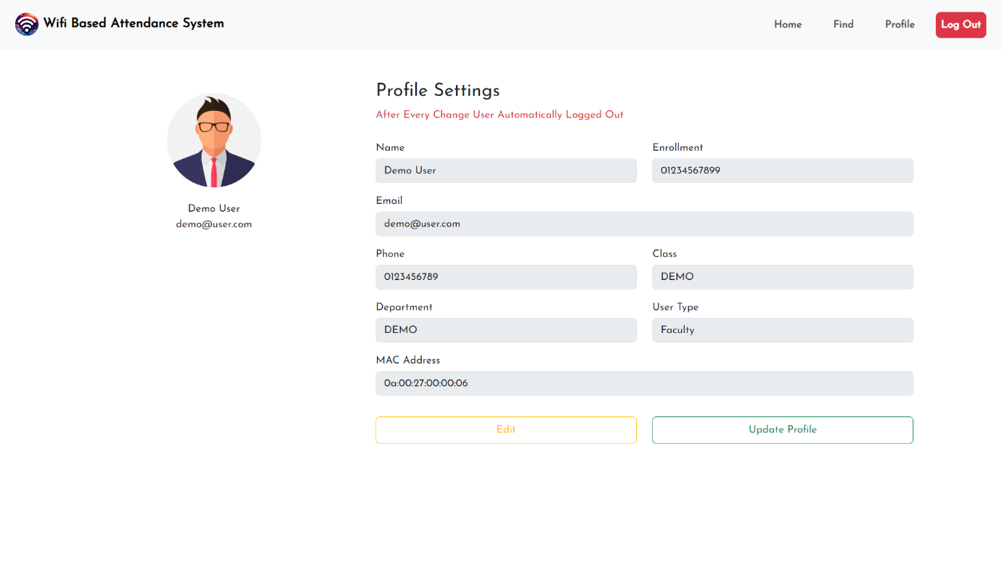

Fig. 4.3.15 Profile Page

# CHAPTER 5

**TESTING**

**5.1 TESTING PLAN / STRATEGY**

Our testing plan/strategy focuses on ensuring the reliability, functionality, and security of our project. Continuous testing throughout the development process will enable us to identify and rectify issues promptly, ensuring a robust and user-friendly system upon deployment.

**5.2 TEST RESULTS AND ANALYSIS**

|  |  |  |  |  |
| --- | --- | --- | --- | --- |
| **TEST ID** | **TEST CONDITION** | **EXPECTED OUTPUT** | **ACTUAL OUTPUT** | **REMARK** |
| TC001 | User enters valid credentials for login. | Successful login message. | Successful login message. | Login functionality works properly. |
| TC002 | User enters invalid credentials for login. | Error message indicating invalid credentials. | Error message indicating invalid credentials. | Validation working properly. |
| TC003 | User attempts to mark attendance within allowed range. | Successful attendance marking. | Successful attendance marking. | Attendance marking works within the range |
| TC004 | User attempts to mark attendance outside allowed range. | Error message indicating out of range. | Attendance marked message displayed. | Need to ensure that if user is out of range the it is not allowed to mark attendance. |
| TC005 | User attempts to mark attendance outside allowed range. | Error message indicating out of range. | Error message indicating out of range. | Ensured that if out of range then not allowed to mark attendance. |
| TC006 | System generates accurate attendance reports. | Report includes correct attendance data. | Report includes correct attendance data. | Accurate report generated. |

Table 5.2.1 Test Result And Analysis

# CHAPTER 6

**CONCLUSION & OUTCOMES**

**6.1 OVERALL ANALYSIS OF PROJECT VIABILITIES**

Our proposed GPS-Based Attendance system here demonstrates strong project viability across multiple dimensions. Firstly, its innovative approach of utilizing MAC address verification coupled with geolocation services enhances security and ensures accurate attendance tracking. This feature-rich system addresses key requirements such as user registration, authentication, attendance marking, and reporting offering comprehensive functionality for both type of users (Student & Faculty). Moreover, the system's scalability and performance optimizations enable it to accommodate increasing user numbers and attendance records while maintaining responsiveness. Its emphasis on security, including encryption and access control measures (MAC Address Authentication) enhances data protection and mitigates risks associated with unauthorized access. Additionally, the availability of report generation of the marked attendance provides useful insights for the analysis of the students. Furthermore, the project's utilization of the MERN stack leverages modern technologies and frameworks, facilitating efficient development, deployment, and maintenance. Overall, our GPS-Based Attendance system exhibits robust project viability, promising significant benefits in terms of efficiency, accuracy, and security for attendance management in diverse environments

.

**6.2 PROBLEM ENCOUNTERED AND POSSIBLE SOLUTIONS**

In the journey of crafting our project, we encountered a couple of hurdles that tested our ingenuity and problem-solving skills. One notable challenge we faced was the vulnerability of our system to unauthorized access. Initially, anyone with the correct credentials could gain entry, posing a significant security risk. To fortify our defenses, we brainstormed and implemented a solution: binding each user's login credentials to their unique MAC address. This simple yet effective measure ensured that only authorized users could access the system, bolstering its security and instilling peace of mind.

Another obstacle we encountered was the unrestricted ability for users to mark their attendance from any location. This loophole jeopardized the accuracy and integrity of our attendance tracking. In response, we rolled up our sleeves and devised a solution that restricted attendance marking to within a predefined location range. By integrating geolocation services, we empowered the system to verify the user's proximity to a specified location before allowing attendance marking. This refinement not only enhanced the reliability of our system but also reinforced its integrity, ensuring that attendance records accurately reflected users' physical presence.

**6.3 SUMMARY OF PROJECT WORK**

Our project is a modern solution to streamline attendance tracking using GPS technology. When users sign up for the system, their device's unique MAC address is securely stored in our database. Upon subsequent logins, the system verifies this MAC address to ensure authorized access. To prevent abuse, users can only mark their attendance if they are within a predefined range, verified through live location tracking. The system is built using the MERN stack, comprising MongoDB, Express.js, React.js, and Node.js, which ensures efficiency and flexibility. By leveraging GPS and MAC address verification, we eliminate the need for traditional methods like ID cards or manual sign-ins, simplifying the process for both users and administrators. Overall, our GPS-Based Attendance system offers a user-friendly and secure solution for organizations seeking a modern approach to attendance management, enhancing efficiency and accuracy while reducing administrative burden.

**6.4 LIMITATIONS AND FUTURE ENHANCEMENT**

1. **Preventing Multiple Attendance Marking:** Currently, users can mark attendance multiple times, causing inaccuracies. To tackle this, we plan to ensure users can only mark attendance once, enhancing data integrity. By implementing this solution, we'll promote fairness and accuracy in attendance records, ensuring each entry reflects a single instance of attendance.
2. **Enhancing Location Precision:** Presently, our system lacks precise location data, limiting its accuracy. To overcome this, we aim to integrate GPS data, enabling pinpoint location accuracy. With this enhancement, we'll ensure that attendance tracking reflects users' actual presence in specified areas, enhancing reliability and trust in the system.

**6.5 PROJECT OUTCOMES**

1. **Streamlined Attendance Tracking:** Our project aims to simplify attendance management by leveraging GPS technology, reducing manual effort and paperwork. With our system, users can effortlessly mark their attendance using their devices, eliminating the need for traditional methods like paper sign-ins.
2. **Enhanced Data Accuracy:** By implementing measures to prevent multiple attendance marking and integrating precise location data, we ensure that attendance records are accurate and reliable. This enhances transparency and trust in the system, providing administrators with dependable data for payroll and performance evaluation.
3. **Improved Efficiency and Productivity:** With streamlined processes and accurate data, organizations can allocate resources more efficiently, optimize scheduling, and identify attendance patterns. This leads to improved productivity and better decision-making, ultimately benefiting the organization as a whole.

# REFERENCES

1. **GPS Based Attendance System (Using Qrcode) By R.Siva kumar, U.Hima kiran, B.Ganesh, V.Rama Rao, Mr. B.Chandra mouli, Mr.R.Chandrasekhar**

<https://ece.anits.edu.in/2019-20%20BE%20Project%20REPORTS/BCM_1920_PROJECT_2.pdf>

1. **Attendance Tracking System Using Wi-Fi (IP Based) By Neil Sharma, Behara Manoj Kumar, Ajay Patil, Abhilash Kale, Nikhil Lamb**

<https://www.erpublication.org/published_paper/IJETR031995.pdf>

1. **Smart attendance system using RFID and Wi-Fi module By Indrayudh Bandyopadhyay. Sayan Chakraborty, Arindam Pyne**

<https://zenodo.org/records/6554182>